

**Data Technician**

|  |
| --- |
|  |

|  |
| --- |
| Name: |
| Course Date: |
|  |

**Table of contents**

Day 2: Task 1 3

Day 2: Task 2 5

Day 4: Task 1 8

Day 4: Task 2 8

Day 4: Task 3 9

Day 4: Task 4 10

**Course Notes** 11

**Additional Information** 12

# Day 2: Task 1

Using the Health [data set](https://justit831-my.sharepoint.com/:u:/g/personal/danpe_justit_co_uk/EZQ21qEcLdVHhvngLvlD4TsBmzGvgh98xkHGxM1XVNCKUg?e=E7UfGi), conduct an analysis to find trends and key information that could be used by an organisation for future support.

**Scenario:**

You are a data analyst working for a global health organization. Your team needs to quickly understand key health trends and disparities across different countries and continents. They are particularly interested in seeing how health metrics vary and how life expectancy has changed over time.

**Your Task:**

Using the GapminderHealth dataset in Tableau, create a series of visualizations to answer the following questions. Focus on using basic chart types and features.

**Instructions & Deliverables:**

1. **Life Expectancy by Continent (Most Recent Year):**
   * Create a **bar chart** showing the average Life Expectancy for each Continent.
   * **Filter** the data to show only the **most recent year** available in the dataset.
     1. (You may need to change datatype for **Year** field)
   * **Sort** the continents by Life Expectancy in ascending or descending order.
   * **Deliverable:** A worksheet named "Life Expectancy by Continent".

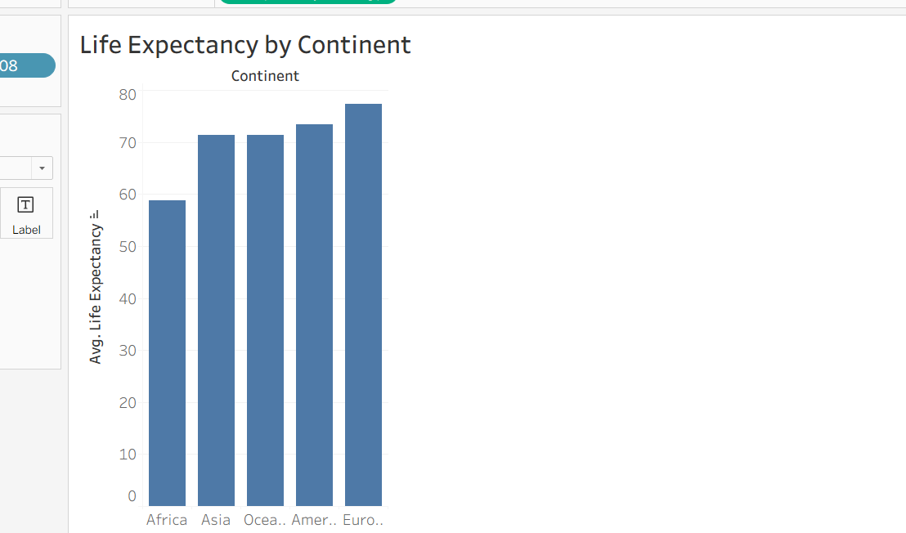

1. **Life Expectancy Trend Over Time (Top 5 Countries):**
   * Create a **line chart** to show the trend of Life Expectancy over Year.
   * **Filter** the data to display only the **top 5 countries** with the highest average Life Expectancy across all years. (Hint: Use a Top N filter on Country based on Average Life Expectancy).
   * Use Country on Color to differentiate the lines.
   * **Deliverable:** A worksheet named "Life Expectancy Trend".

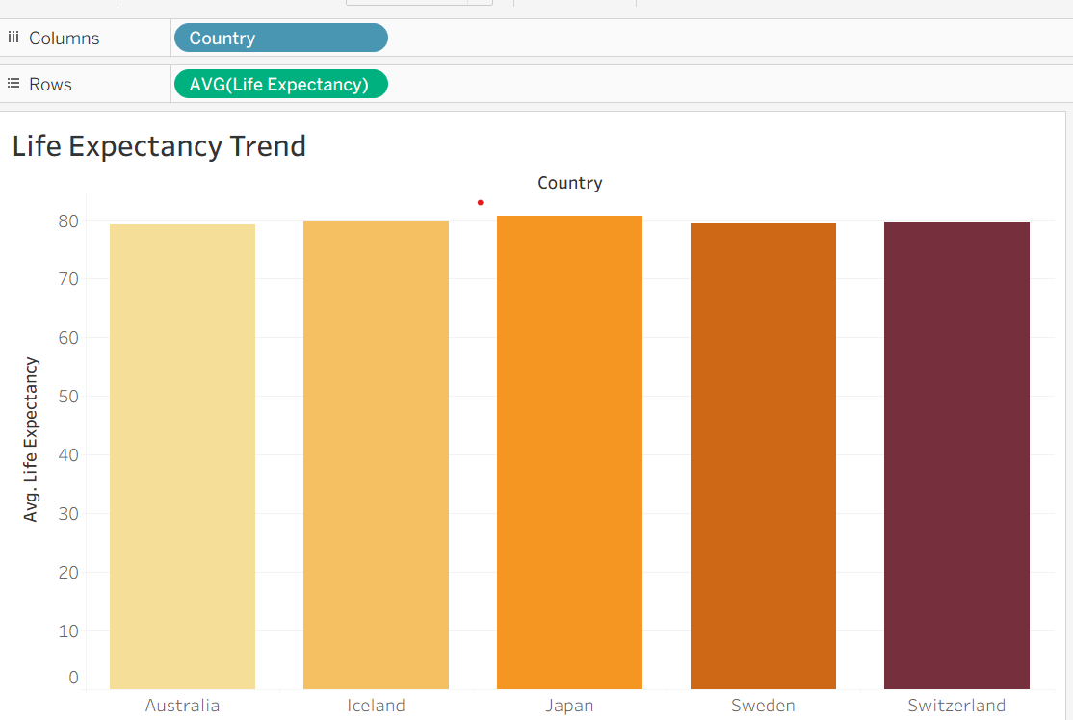

1. **Population Distribution by Gender (Latest Year for a Selected Country):**
   * Create a **pie chart** showing the Population distribution by Gender.
   * **Add a Country filter** to the worksheet (e.g., set it to 'United States' or a country of your choice initially, but ensure the filter is available for interaction). Change filter type to Single Value (dropdown).
   * **Filter** the data to show only the **most recent year** available in the dataset.
   * **Add Population to Labels.** Right click on sum(Population) under marks card and change **Quick table calculation to Percentage of Total.**
   * **Deliverable:** A worksheet named "Population by Gender".

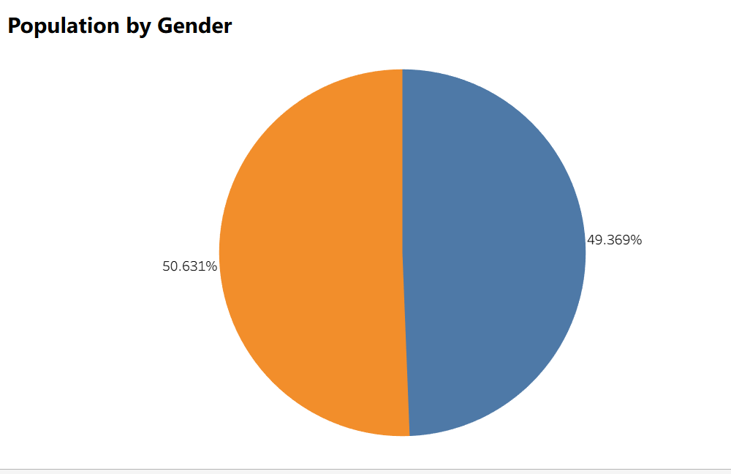

1. **Health Metric Comparison (Scatter Plot):**
   * Create a **scatter plot** to explore the relationship between Average Life Expectancy and Average BMI.
   * Place Life Expectancy on one axis and BMI on the other.
   * Use Country on Detail to represent individual countries as points.
   * Use Continent on Color to differentiate points by continent.
   * Add Continent to filters and show filter.
   * **Deliverable:** A worksheet named "Life Expectancy vs BMI".

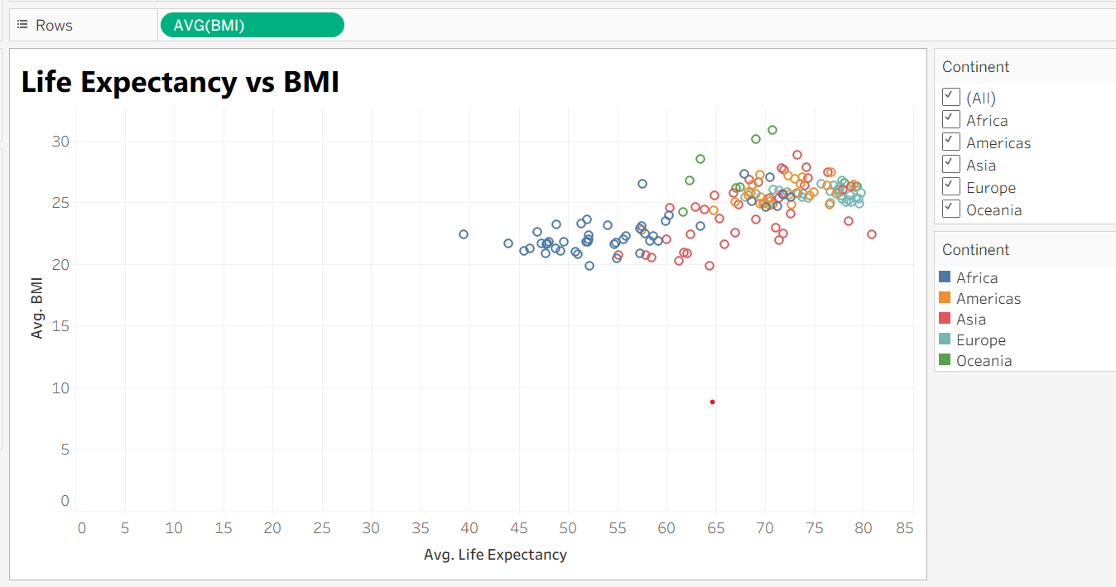

1. **Viz of your Choice**
   * Use any other fields or chart types to add another visual.

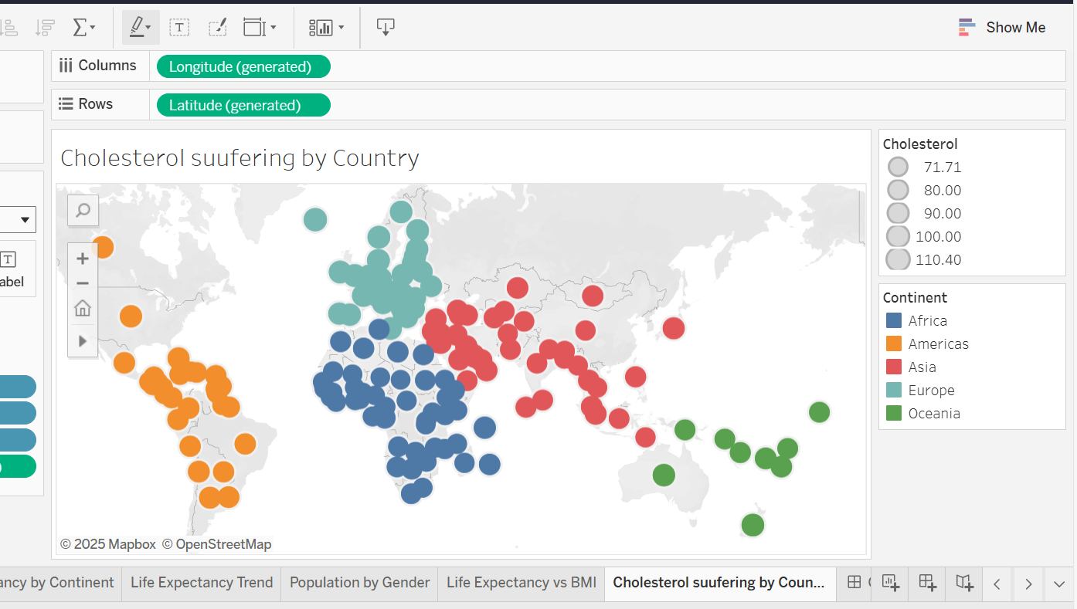

1. **Dashboard Creation:**
   * Combine all worksheets (Life Expectancy by Continent, Life Expectancy Trend, Population by Gender, Life Expectancy vs BMI, Viz of your Choice) into a **single dashboard**.
   * Ensure the "Country" filter on the "Population by Gender" worksheet applies to the "Life Expectancy Trend" worksheet as well (if applicable, or make it a global filter if you prefer the user to select one country to see all relevant details for it). *Self-correction: Given it's basic, let's keep the filters simple. Just place the filter on the dashboard and ensure it's applied to the relevant sheet(s) where it makes sense.*
   * Add a **Title** to your dashboard, e.g., "Global Health Insights".
   * **Deliverable:** A dashboard named "Global Health Dashboard".

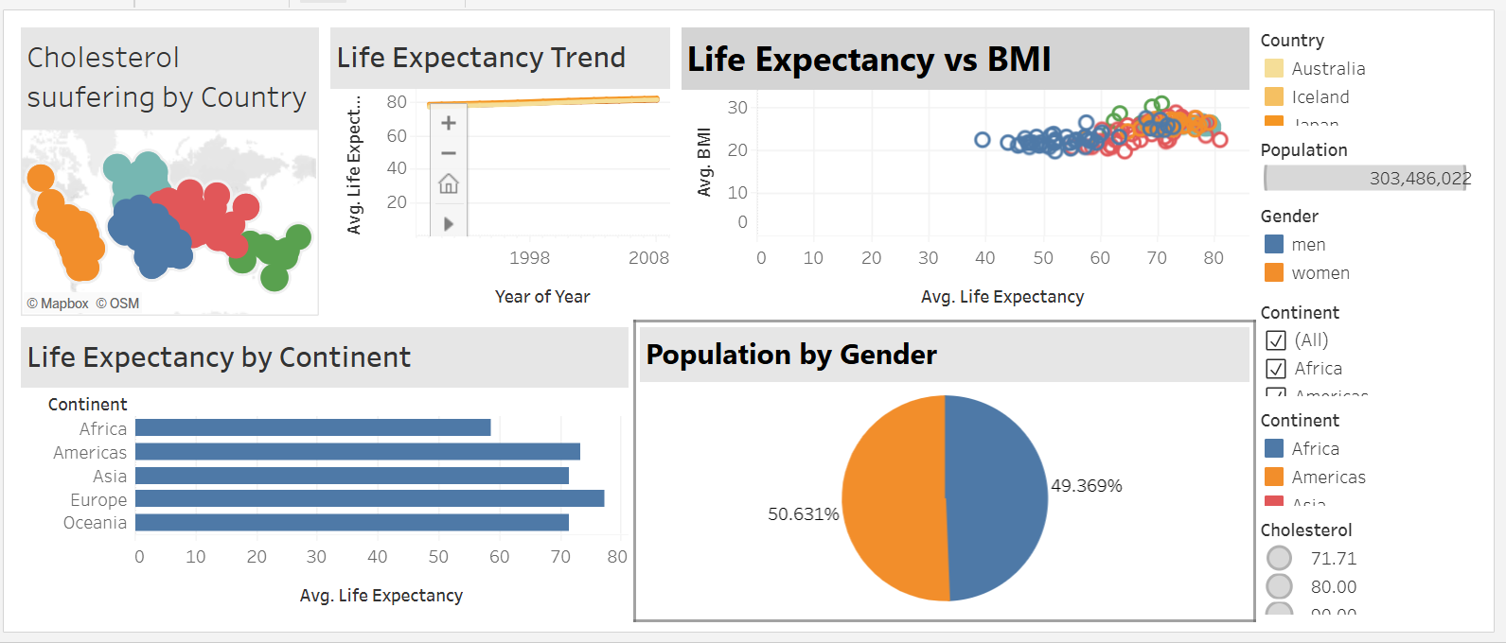

|  |  |
| --- | --- |
| Paste your dashboard screens here | [Global Health Dashboard | Tableau Public](https://public.tableau.com/app/profile/penda.mbaye.ka/viz/Globalhealthdashboard/GlobalHealthDashboard#1) |
| What did you find and any reflections on how the NHS could use this? | My findings regarding the global heath for the NHS are:   * Looking at the bar charts I have noticed that the United Kingdom is one of the top 3 countries with the highest total cancer cases alongside Germany and Italy. * Cancer rate by population is 0.002% * Europe is the 3rd continent with the highest life expectancy and Africa is the last one. * The European Continent has the highest group of people with cholesterol and it’s mostly with men.   **My conclusion:**  Considering all information provided, although the European continent is ha some of the highest life expectancy, the cholesterol is high. What the NHS should reflect on is the lifestyle of its patients to improve their health considering these visualisations. Continue to advocate for a better and healthy diet plan, hopefully pushing it to be mandatory one day throughout the whole country. |

# Day 2: Task 2

Using the Spotify data set, conduct an analysis to find trends and key information that could be used by an organisation for future projects. [Download dataset here](https://b2wcompletetraining057-my.sharepoint.com/:x:/g/personal/yusufs_justit_co_uk/EVqNbbG9HeRDnTPJIcxnp2gBlKPjxB-l8NyhrmdJ2LNFMw?e=pPzhU2).

**Column Description**

* **genre**: The genre in which the track belongs
* **artist_name**: The artists' names who performed the track. If there is more than one artist, they are separated by a ;
* **track_name**: Name of the track
* **track_id**: The Spotify ID for the track
* **popularity**: **The popularity of a track is a value between 0 and 100, with 100 being the most popular**. The popularity is calculated by algorithm and is based, in the most part, on the total number of plays the track has had and how recent those plays are. Generally speaking, songs that are being played a lot now will have a higher popularity than songs that were played a lot in the past. Duplicate tracks (e.g. the same track from a single and an album) are rated independently. Artist and album popularity is derived mathematically from track popularity.
* **acousticness**: A confidence measure from 0.0 to 1.0 of whether the track is acoustic. 1.0 represents high confidence the track is acoustic
* **danceability**: Danceability describes how suitable a track is for dancing based on a combination of musical elements including tempo, rhythm stability, beat strength, and overall regularity. A value of 0.0 is least danceable and 1.0 is most danceable
* **duration_ms**: The track length in milliseconds
* **energy**: Energy is a measure from 0.0 to 1.0 and represents a perceptual measure of intensity and activity. Typically, energetic tracks feel fast, loud, and noisy. For example, death metal has high energy, while a Bach prelude scores low on the scale
* **instrumentalness**: Predicts whether a track contains no vocals. "Ooh" and "aah" sounds are treated as instrumental in this context. Rap or spoken word tracks are clearly "vocal". The closer the instrumentalness value is to 1.0, the greater likelihood the track contains no vocal content
* **key**: The key the track is in. Integers map to pitches using standard Pitch Class notation. E.g. 0 = C, 1 = C♯/D♭, 2 = D, and so on. If no key was detected, the value is -1
* **liveness**: Detects the presence of an audience in the recording. Higher liveness values represent an increased probability that the track was performed live. A value above 0.8 provides strong likelihood that the track is live
* **loudness**: The overall loudness of a track in decibels (dB)
* **mode**: Mode indicates the modality (major or minor) of a track, the type of scale from which its melodic content is derived. Major is represented by 1 and minor is 0
* **speechiness**: Speechiness detects the presence of spoken words in a track. The more exclusively speech-like the recording (e.g. talk show, audio book, poetry), the closer to 1.0 the attribute value. Values above 0.66 describe tracks that are probably made entirely of spoken words. Values between 0.33 and 0.66 describe tracks that may contain both music and speech, either in sections or layered, including such cases as rap music. Values below 0.33 most likely represent music and other non-speech-like tracks
* **tempo**: The overall estimated tempo of a track in beats per minute (BPM). In musical terminology, tempo is the speed or pace of a given piece and derives directly from the average beat duration
* **time_signature**: An estimated time signature. The time signature (meter) is a notational convention to specify how many beats are in each bar (or measure). The time signature ranges from 3 to 7 indicating time signatures of 3/4, to 7/4.
* **valence**: A measure from 0.0 to 1.0 describing the musical positiveness conveyed by a track. Tracks with high valence sound more positive (e.g. happy, cheerful, euphoric), while tracks with low valence sound more negative (e.g. sad, depressed, angry)

There is no set scope for the analysis, simply to find trends and document them below:

|  |  |
| --- | --- |
| Paste your print screens here | [Spotify Dataset Hindsight | Tableau Public](https://public.tableau.com/app/profile/penda.mbaye.ka/viz/SpotifyDatasetHindsight/SpotifyDatasetHindsight#1) |

|  |  |
| --- | --- |
| What did you find? | The information I found based on these visualisations are:   * Drake is the most popular artist. * The most danced genre is hip hop * Pop is the 5th most danced genre * Most popular track is Taki Taki by Cardi B, Selena Gomez and Ozuna * Cardi B has two popular tracks that are in the top 5 average popularity. * Guiseppe Verdi is the top artist out of the 5 liveliest ones by genre with his opera.   **Tutorial Power BI:**    [Class Enrollment: Penda Mbaye Ka, PL-300T00-A Design and Manage Analytics Solutions Using Power BI [Cloud Slice Provided] - Skillable TMS](https://justit.learnondemand.net/ClassEnrollment/5272484) |

# Day 4: Task 1

Please complete Lab: ‘Get Data in Power Bi Desktop’. Once complete, paste a print screen below and in the collaboration board.

“Teaching is the best way to learn, so please listen out for support requests from the class and we’ll work through the challenges together”

|  |  |
| --- | --- |
| Paste your completed lab here | [Class Enrollment: Penda Mbaye Ka, PL-300T00-A Design and Manage Analytics Solutions Using Power BI [Cloud Slice Provided] - Skillable TMS](https://justit.learnondemand.net/ClassEnrollment/5272484) |

# Day 4: Task 2

Please complete Lab: ‘Load Transformed Data in Power BI Desktop’. Once complete, paste a print screen below and in the collaboration board.

“Teaching is the best way to learn, so please listen out for support requests from the class and we’ll work through the challenges together”

|  |  |
| --- | --- |
| Paste your completed lab here | [Class Enrollment: Penda Mbaye Ka, PL-300T00-A Design and Manage Analytics Solutions Using Power BI [Cloud Slice Provided] - Skillable TMS](https://justit.learnondemand.net/ClassEnrollment/5272484)      [Class Enrollment: Penda Mbaye Ka, PL-300T00-A Design and Manage Analytics Solutions Using Power BI [Cloud Slice Provided] - Skillable TMS](https://justit.learnondemand.net/ClassEnrollment/5272484) |

# Day 4: Task 3

Please complete Lab: ‘Design a Report in Power BI Desktop’. Once complete, paste a print screen below and in the collaboration board.

“Teaching is the best way to learn, so please listen out for support requests from the class and we’ll work through the challenges together”

|  |  |
| --- | --- |
| Paste your completed lab here | [Class Enrollment: Penda Mbaye Ka, PL-300T00-A Design and Manage Analytics Solutions Using Power BI [Cloud Slice Provided] - Skillable TMS](https://justit.learnondemand.net/ClassEnrollment/5272484) |

# Day 4: Task 4

Please complete Lab: ‘Create a Power BI Dashboard’. Once complete, paste a print screen below and in the collaboration board.

“Teaching is the best way to learn, so please listen out for support requests from the class and we’ll work through the challenges together”

|  |  |
| --- | --- |
| Paste your completed lab here | [Class Enrollment: Penda Mbaye Ka, PL-300T00-A Design and Manage Analytics Solutions Using Power BI [Cloud Slice Provided] - Skillable TMS](https://justit.learnondemand.net/ClassEnrollment/5272484) |

|  |
| --- |
| **Course Notes** |

It is recommended to take notes from the course, use the space below to do so, or use the revision guide shared with the class:

|  |
| --- |
| **Additional Information** |

We have included a range of additional links to further resources and information that you may find useful, these can be found within your revision guide.

**END OF WORKBOOK**

**Please check through your work thoroughly before submitting and update the table of contents if required.**

**Please send your completed work booklet to your trainer.**